**ABOUT US**

[**NewsMobile**](http://www.newsmobile.in/) is an independent news organisation founded by a team of award-winning journalists. Our journalists are objective and we have a policy to ensure that our journalists are not affiliated to any political party or an advocacy group and we are fair and transparent in our editorial opinion.

[**www.newsmobile.in (NewsMobile)**](http://www.newsmobile.in/) is the news and content platform of World Mobile News Network Pvt Ltd, a private limited company registered in India. Our funding was provided by our co founders who are senior journalists and media academics from their personal savings.

As an unbiased and objective digital news platform, powered by cutting edge technology, our aim is to highlight stories that impact people and present credible and fact-checked stories to our readers.

We have a special section on [**NM Fact Checker**](http://newsmobile.in/articles/category/nm-fact-checker/), we debunk fake news by putting verified facts before the readers. When we come across a claim or it is brought to our notice, we check it for factual accuracy. Our platform also features breaking news, exclusive stories and user-generated content selected by our team. In the four years of our existence, we found fake new spreading more than the correct news, harming people and setting off reactions. We started independent fact-checking in January 2017, when fake news started not only confusing but influencing people. If a correction has been brought to our notice we have gone ahead and corrected the stories after verifying the claims.

Through our modest means our [**NM fact-checker**](http://newsmobile.in/articles/category/nm-fact-checker/) team comprising of young journalists trained by Google news labs and our senior journalists, have followed the following methodology to fact check stories that appear in [NM Fact Checker](http://newsmobile.in/articles/category/nm-fact-checker/) section. Our Fact Checking and efforts to bust fake news have also been featured in a special TV show on fact checking by [Facebook on Republic TV](https://www.republicworld.com/initiatives/one-india/one-india-the-battle-to-save-the-truth).

**How We Fact Check**

* **Importance of the story**: How important is the story, and can it create a potentially dangerous situation, the likelihood of a communal riot or can it harm a community, or can it create panic in communities.
* **Tracking the source:** We track the source of the claim and then cross-check with multiple sources. If a public figure or person of authority has made the claim then we reach out to them directly to confirm the claim. If there is video evidence, publicly available transcript, report or data we take a deep-dive approach to find the exact quote and context. If need be, we contact the organisation that has published the reports to understand the disclaimer.
* **Use Tools/technology:** We use Google and other tools like *google reverse news* to knock down and derail fake claims. We sift through reams of data and databases to support a claim or debunk a claim. If there is not enough data to take a clear stand, we say that too
* **Panel of Experts**: This is often important because as a news organisation we do not claim expertise in every field. However, we have a network of experts who understand our commitment to factual accuracy and help us maintain high standards
* Preparing a fact sheet.
* And then a fact-based story is put out.

* **Correction Policy:** Facts and truth are at the centre of Newsmobile’s Editorial policy, our team of journalists have broken stories on corruption at high places questioned those in power and we are fearless, unbiased and objective. We have an impeccable record as a credible media outlet. However, as a responsible Media outlet, we are open to corrections. We invite readers to write to us at [editor@newsmobile.in](mailto:editor@newsmobile.in)  with a date and link to the story and we fact-check the claim and correct it.
* **Correction Advisory:** While we have been very particular about correcting the inadvertent errors right from the word go, irrespective of whether was pointed out by our readers, our network of experts, competition or by our own team members, we have recently started adding an ‘editor’s note’ at the end of stories that have been corrected. This is in the interest of transparency and in tandem with the global best practices.
* **Fact Checking Hotline:** We have a Fact Check Alert number for Whats app +91-8826800707. Readers are invited to forward a new story or a message on social media that they would like to get fact-checked. They can also e-mail it at editor@newsmobile.in with the title Fact Check and our Fact Checking team will check the story and publish the truth.
* NewsMobile is active on social media platforms like [**Twitter**](https://twitter.com/NewsMobileIndia)**,**[**Facebook**](https://www.facebook.com/NewsMobile/)and [**Instagram**](https://www.instagram.com/newsmobileindia/)

**THE TEAM**

**Dr SC SHUKLA**

**Editorial Director and Co-Founder**

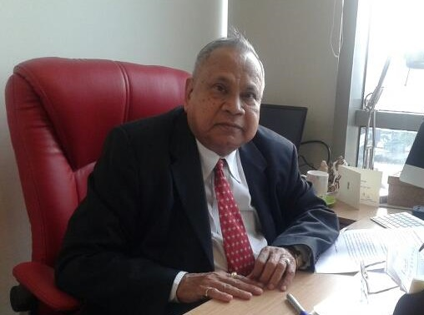

The Founder Principal of Delhi College and Arts and Commerce founded the biggest ever nursery of journalists in India where he mentored some of the best known young journalists in India. Credibility, integrity and fact checking are the mantras he provided us for NewsMobile and its young team. He is the conscience keeper and disciplinarian to our wayward gang of news hounds and techies.

[**SAURABH SHUKLA**](http://newsmobile.in/articles/author/saurabhshukla/)

**Editor in Chief and Co-Founder**

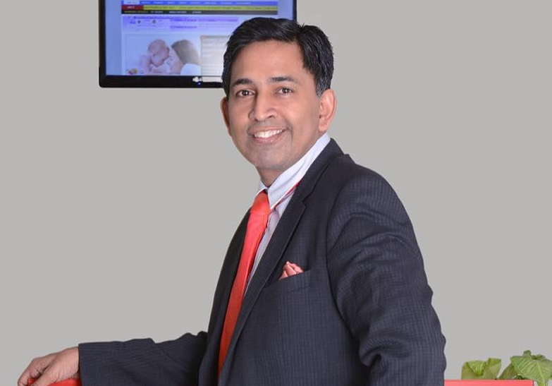

Saurabh has over twenty years of journalism experience. He has been known for his fearless journalism. He has interviewed many global leaders, during an interview, he asked Donald Trump to apologise for his anti-women remarks. He broke the Dawood tapes, the first exclusive tapes on India’s most wanted fugitive.

He has exposed corruption in high places. His expose on Indian connection on Iraq’s oil for food scandal forced the resignation of India’s then Foreign Minister K.Natwar Singh.  
He has been known for his credible journalism. He has served in leadership roles in Top Indian media organisations The India Today Group, Indian Express and Hindustan Times. He is been quoted in the New York Times and The Guardian and has been a commentator for many global channels.

Email: saurabh@newsmobile.in

[**ABHEET RAGHAV**](http://newsmobile.in/articles/author/abheetraghav/)

**Senior News Editor**

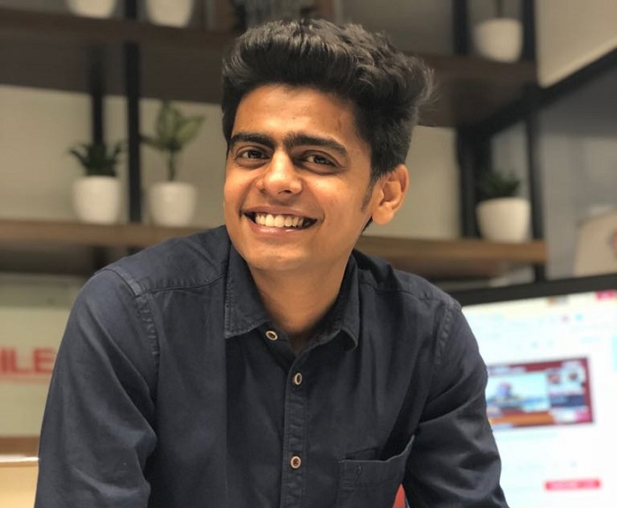

He is passionate about fair and transparent reporting. Whenever a claim is made he leaves no stone unturned in identifying the source. He is working with NewsMobile for last three years. He underwent Google training for identifying and checking fake news and utilizes it to fact-check.

Email: abheet@newsmobile.in

[**NINA MEHTA**](http://newsmobile.in/articles/author/nina-mehta/)

**Senior Editor**

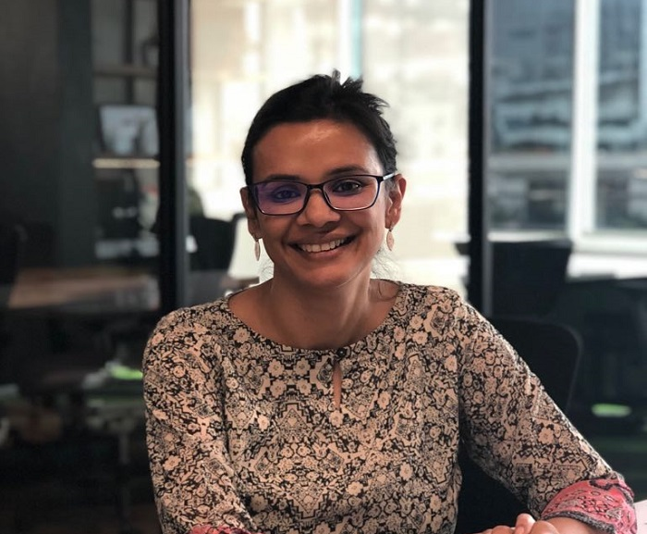

She has 16 years of experience in content creation and delivery. She has worked with print media and newswires where global best practices of reporting and accuracy were then the norm. The experience with Dow Jones Newswires deeply ingrained in her the principles of ethical journalism and factual reporting. She spent over four years working in Hindustan Times in Delhi covering the major business stories in the first decade of this century.

Email: nina@newsmobile.in

[**KSHIPRA NARAIN**](http://newsmobile.in/articles/author/kshipranarain/)

**Editor Special Projects**

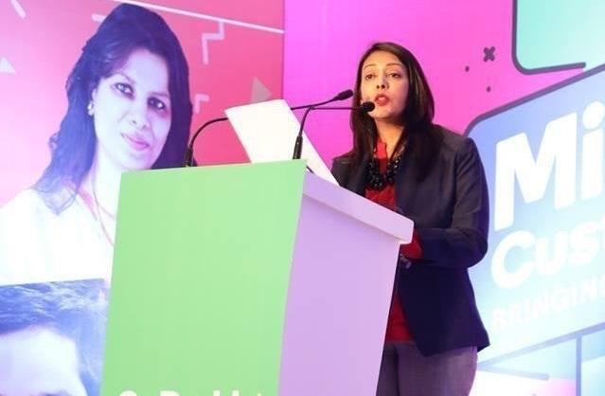

She joined online media two years ago after spending a decade in the corporate world. She is particular about getting the facts right and ensures that everyone on the team follows the practice of fair and non-partisan reporting.

Email: kshipra@newsmobile.in

[**PRIYANSHI MATHUR**](http://newsmobile.in/articles/author/priyanshimathur/)

**Associate Feature Editor**

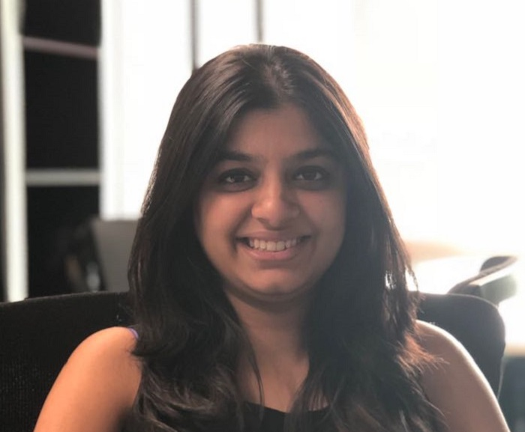

Priyanshi Mathur is a journalism graduate from India’s top college Lady Shri Ram (LSR). She has been working with NewsMobile for two years. She underwent Google training for identifying and checking the fake news.

Email: priyanshim12@gmail.com

[**SAJEELI GUPTA**](http://newsmobile.in/articles/author/sajeeligupta/)

**Associate Editor**

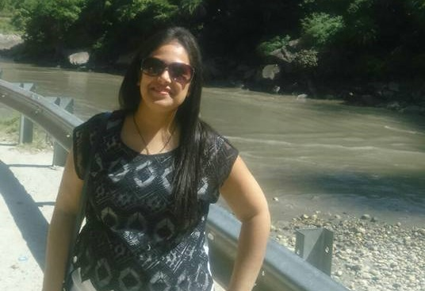

Her motto is to “live to eat and enjoy life to the fullest”. She has over six years of experience in food and lifestyle. After completing her masters in Mass Communication, she was a features writer at India Times. Helpful by nature she goes beyond the call of duty to ensure that each fact in any claim is cross-referenced and only then appears on the news platform.

Email: sajeeli@newsmobile.in

**NEHA PARASHAR**

**Correction Editor**

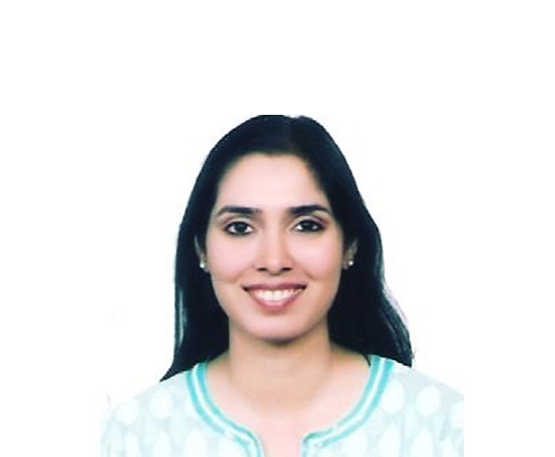

She is a Journalism graduate and management graduate from Symbiosis University Pune. She has a keen eye for copy editing and fact-checking. As a consultant, Neha helps NewsMobile fact-check news stories and ensure credible and error-free news stories.

(In order to ensure objectivity and transparency we have a corrections Editor who works independent of our newsroom)

**PRADEEP SINGH**

**Technical Director**



PK, as he is fondly called, is a tech war veteran from the Silicon Valley and IIT Delhi. He provides the tech edge for our fact-checking. He keeps the tech fundas up to speed and delivers on our crazy ideas of creating different content with cutting-edge technology.