Sample story

https://verafiles.org/articles/vera-files-fact-check-viral-fb-posts-make-inaccurate-claims

In the MS Word version of the text below, the underlined portion—a hyperlink—was explicitly seen as a clickable link.

**On the conflict between the Lopezes and Marcos due to tax issues**

The conflict between the Lopezes and Marcos was due to the ownership of a lubricating oil facility — not taxes — from which the president demanded a 40 percent share, a proposition the Lopezes rejected by offering 15 percent to the president instead.

Historian Joseph Paul Scalice, in his [2017 dissertation on Marcos’ military rule](https://digitalassets.lib.berkeley.edu/etd/ucb/text/Scalice_berkeley_0028E_17195.pdf), discussed the tension between the two parties during the 1970 economic crisis:

But in the web version, owing perhaps to HTML coding technicalities, the underlined phrase is not underlined. More so, the color of the font may not be easily recognizable to the reader *as a URL* given the white background of the website.

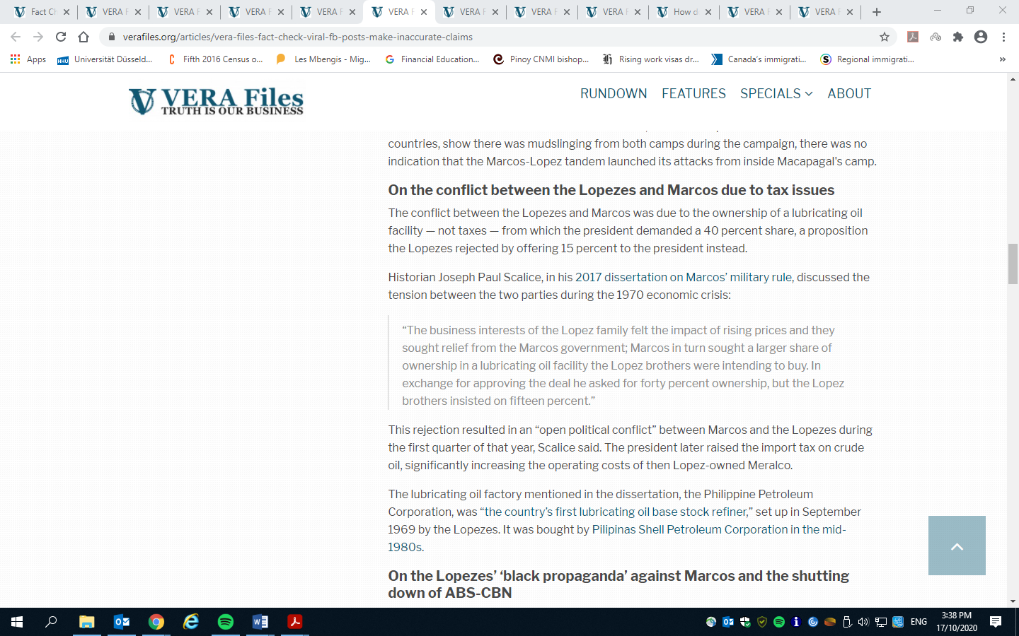

Of course for those who know journalism, we know the purposes of these hyperlinks. But for ordinary readers, their eyes may not easily see that this hyperlink is in fact **a piece of evidence of the fact-checking** done by the news organization. With its web developer, we suggest that Vera Files have these hyperlinks presented more evidently. Doing so also educates readers that these hyperlinks provide evidence to back up your fact checking and research. More importantly, this measure can bolster the editorial transparency of your fact-checking. Examples can include the following (in the context that *the background of the website remains white*):

Different font, in **bold face** in his [**2017 dissertation on Marcos’ military rule**](https://digitalassets.lib.berkeley.edu/etd/ucb/text/Scalice_berkeley_0028E_17195.pdf),

Different font, with underline in his [2017 dissertation on Marcos’ military rule](https://digitalassets.lib.berkeley.edu/etd/ucb/text/Scalice_berkeley_0028E_17195.pdf),